Lamar FFA Newsletter

**November 1, 2016**

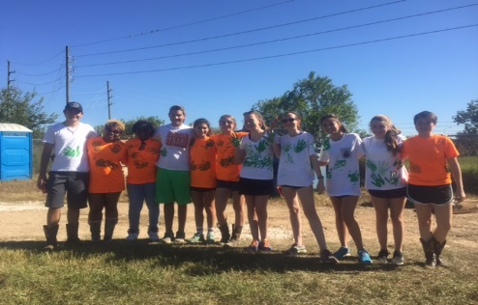

***Officers and Greenhands***

**GREENHAND Camp**

Greenhand Camp is a chance for all first year FFA members to get to know each other, as well as the officers. Greenhand Camp can be thought of as an initiation into FFA. At this year’s GH camp, we carved pumpkins, roasted pumpkin seeds, and caught lambs. The highlight of the day was dipping our hands in paint, and printing them on each other’s shirts.

Officer Helpers

* Karina – Lambs
* Kaitlyn – Horticulture/Floriculture
* Kamryn – LDE’s/CDE’s
* Marco – Pigs/Cattle
* Hannah – Rabbits/Chickens/Pigs
* Faith - Goats

***2016 LDE’s***

LDE’S

* LDE stands for Leadership Development events. Students are encouraged to participate in these events because, they promote premier leadership skills.
* District LDE’S
* November 7th, 2016
* This year Lamar placed 4th in the job interview portion of the district LDE’s
* Area LDE’s
* November 19th, 2016

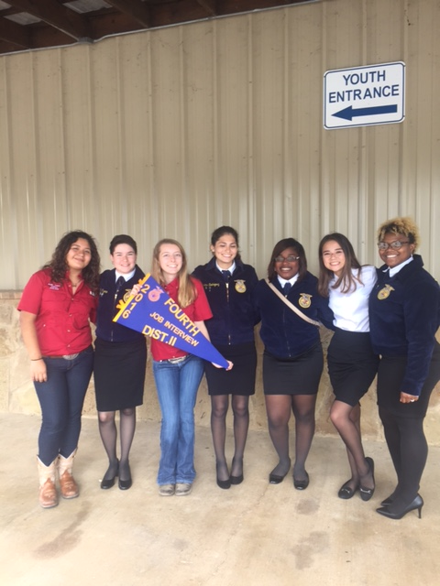

**Christmas Party**

* December Meeting will start at 4:15 (parent meeting will still be at 6pm)
* Potluck – Everyone must pitch in and bring some kind of food, in other words: if you want food, bring food
* We are participating in Toys for Tots this year, and we are asking you guys to help up. Instead of getting Christmas presents, donate to Toys

**Lamb and Goat Fall Clinics**

* Sunday, November 20th, 2016, at 6:30pm
* Wednesday, November 3oth, 2016, at 6:30pm
* Sunday, December 4th, 2016, at 6:30 pm
* Sunday, December 11th, 2016, at 6:30pm

These dates are **MANDATORY** to participate in the Lamar Livestock Show & Auction

**Important Information**

**Toys for Tots**

* brand new
* unopened
* unwrapped
* gender neutral
* no stuffed animals

**Important Barn Information**

* No riding/sitting on your animals
* Spot clean your pin every **3** days
* Change the water every day
* No stealing feed (buy your own supplies)
* Make sure to keep up with chore chart
* Make sure to change water everyday
* Keep your animal clean
* Make sure that the waste gets as far back to the fence as possible! Do NOT leave any waste on the walkway!

**Fundraisers**

* Open poinsettia sales start at the end of November
* Pre-orders will be here: